Master’s Research Project
Assignment 6 – Wireframes Design
Developing an Information System to Optimize Supply Chain Operations for Sysco

School of Professional Studies, Saint Louis University
Professor: Annamaria Szakonyi
Due Date: 19th March 2025
By
Team 15

Bala Surya Peruri
Madhuri Pothu
Rasool Babu Yavara
Siva Ganesh Karthik Guptha Motamarri
Srikar Reddy Regatte
Venkata Rahithya Sopalli

Wireframes

Key Screens & Navigation Flow
Dashboard Overview:
- Displays inventory levels, pending orders, waste reduction insights.
- Includes navigation buttons to access other modules.
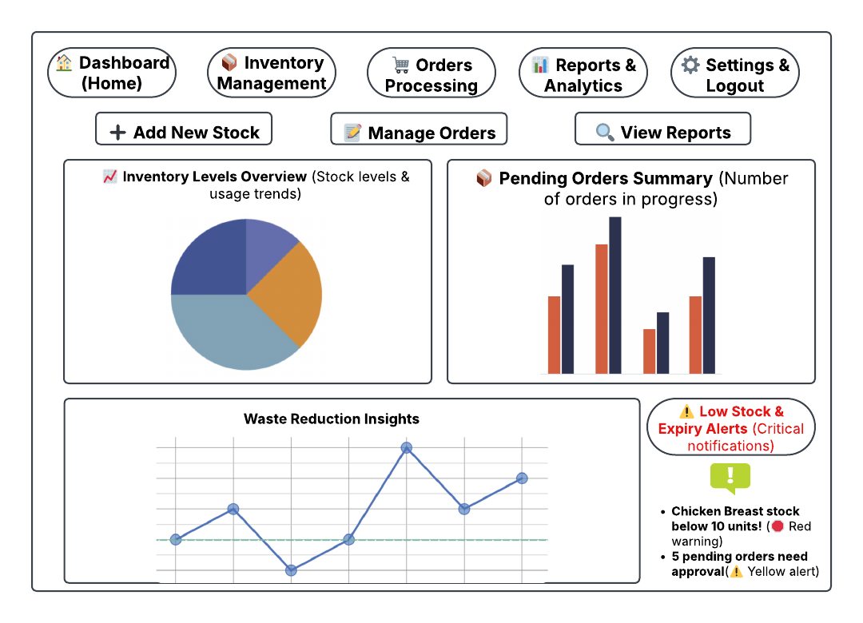
Inventory Management:
- Users can search, filter, and manage stock.
- Low stock alerts & restock options are available.

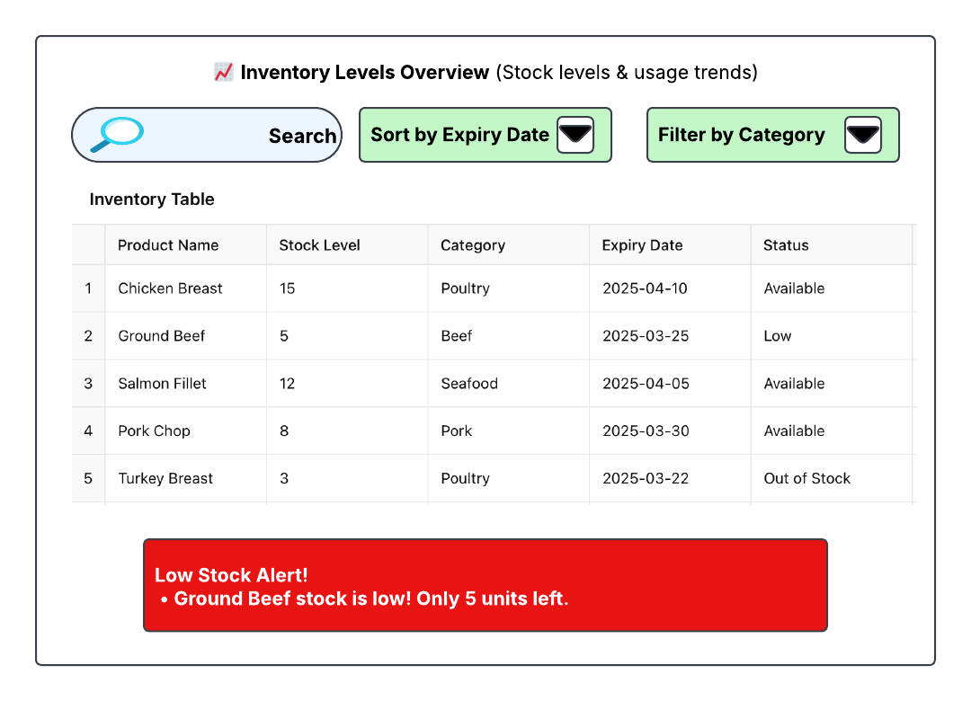
Order Processing:
- Displays pending, approved, and canceled orders.
- Users can approve, modify, or cancel orders.
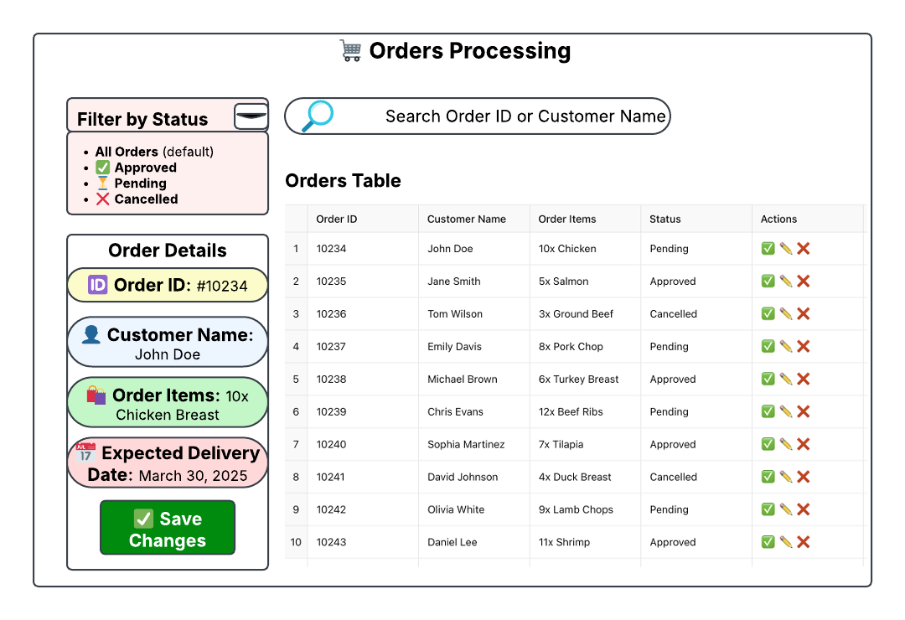
Reports & Analytics:
- Provides sales trends, stock utilization, and waste reports.
- Export options allow downloading data in PDF/CSV formats.
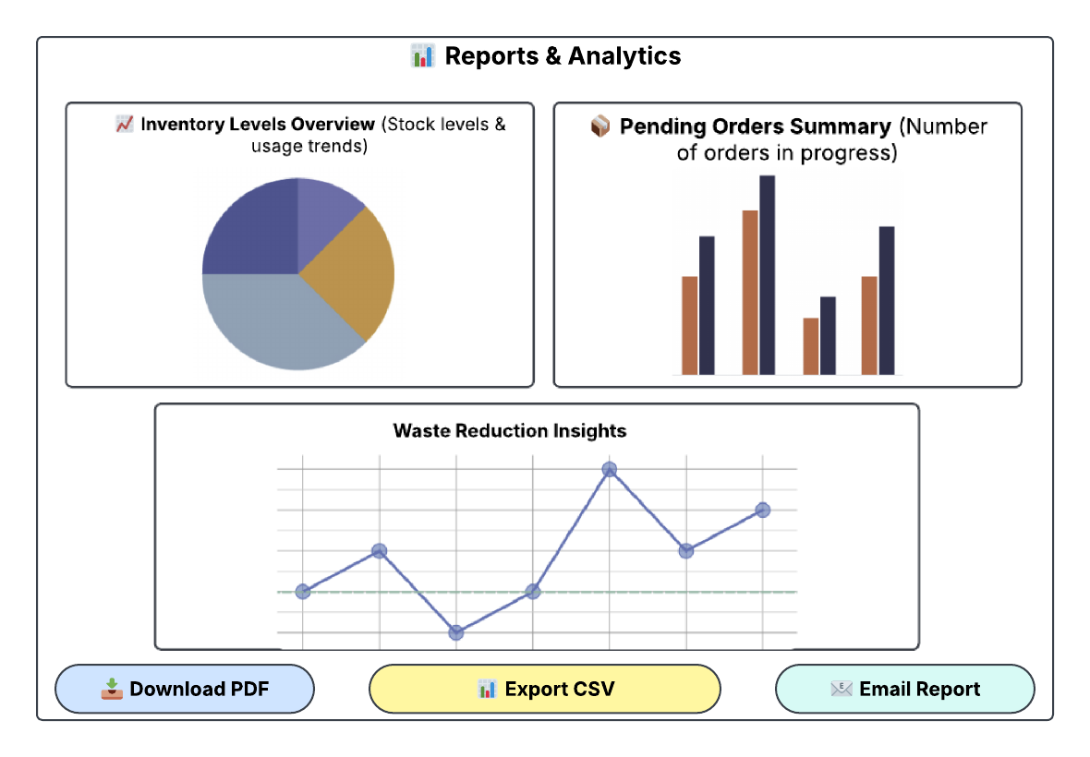
Settings & User Profile:
- Allows users to edit profile details, adjust preferences, and log out securely.

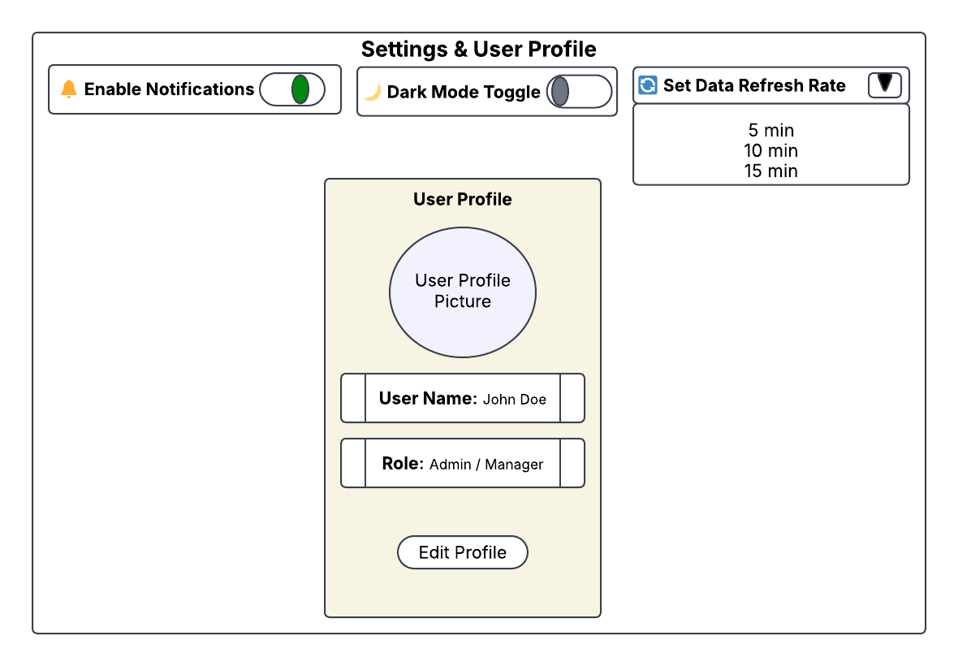

Navigation Flow
Users move through the system as follows:
- Login → Dashboard → Inventory/Orders/Reports/Settings
- From Inventory → Search, Filter, Restock Products
- From Orders → View, Approve, Modify, or Cancel Orders
- From Reports → Analyze trends & export data
- From Settings → Edit profile, set preferences, log out

